Fundamentals of Computer Networking

This tutorial will discover the definition of computer networking, its types, computer networks work, networking concepts, commonly used terms, networking and internet, how it works, and network topologies.

What is a Computer Network?

***"A Computer Network is defined as a set of two or more computers that are linked together?either via wired cables or wireless networks i.e., WiFi?with the purpose of communicating, exchanging, sharing or distributing data, files and resources."***

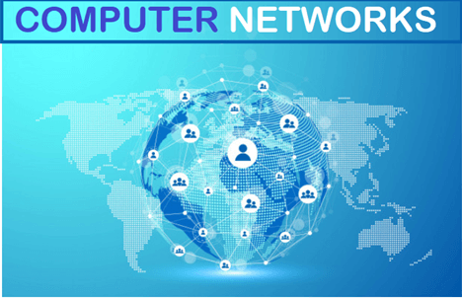

Computer Networks are built using a collection of hardware (such as **routers, switches, hubs, and so forth)** and networking software (such as **operating systems, firewalls, or corporate applications).**

Though one can also define the computer networks based on their geographic location, a **LAN (local area network)** connects computers in a definite physical dimension, such as **home or within an office.**

In contrast, a **MAN (Metropolitan area network)** connects computers ranging between multiple buildings in a city.

The **Internet** is the most significant example of **WAN (Wide Area Network),** connecting billions of networking devices across the world.

One can also describe the concept of computer networking by its communicating protocols, the physical arrangement of its networking elements, how it manages network traffic, and it's functioning.

Computer networks are globally used by businesses, the entertainment industry, education in the research field for communication and transferring their data from source to destination node.

All the other technologies, including the **internet, Google search, instant messaging apps, online video streaming, social media, email, cloud kitchen, cloud data storage,** etc., all exist because of computer networks.

Computer Network Types

Below are the most common computer network types that are frequently used these days:

* **LAN [Local Area Network}**
* **WLAN [Wireless local area network]**
* **CAN [Campus Area Network]**
* **MAN [Metropolitan Area Network]**
* **PAN [Personal Area Network]**
* **SAN [Storage Area Network]**
* **VPN [Virtual Private Network]**
* **WAN [ Wide Area Network]**

1. LAN

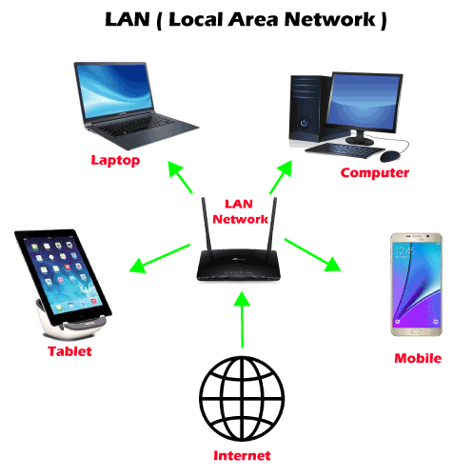

***LAN or Local Area Network*** is a group of devices connecting the computers and other devices such as **switches, servers, printers,** etc., over a short distance such as office, home. The commonly used LAN is **Ethernet LAN.** This network is used as it allows the user to transfer or share data, files, and resources.

2. WLAN

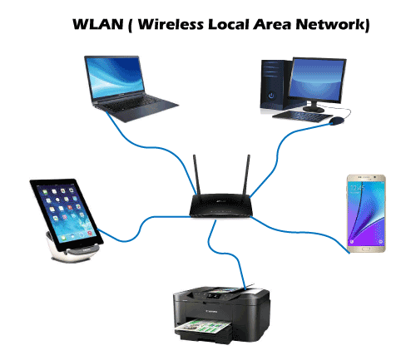

***WLAN or Wireless local area network*** is similar to LAN with the difference that it uses wireless communication between devices instead of wired connections. WLAN typically involves a **Wi-Fi router or wireless access point for devices,** unlike **smartphones, laptops, desktops,** etc.

3. CAN

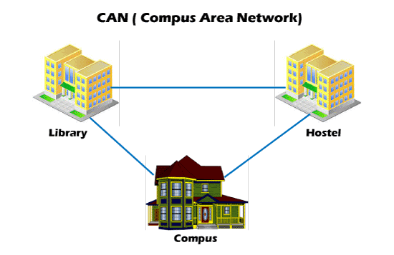

***CAN or Campus Area Network*** is a closed corporate communication network. A CAN is a mobile network that may contain a private or public part. CANs are widely used **colleges, academies, and corporate sites.**

4. MAN

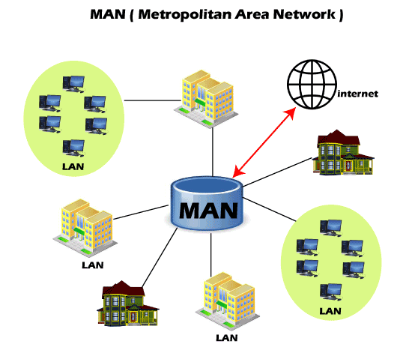

***MAN or Metropolitan Area Network*** is typically a more extensive network when compared to LANs but is smaller than WANs. This network ranges between several buildings in the same city. Man networks are connected via fiber optic cable (usually high-speed connection). Cities and government bodies usually manage MANs.

5. PAN

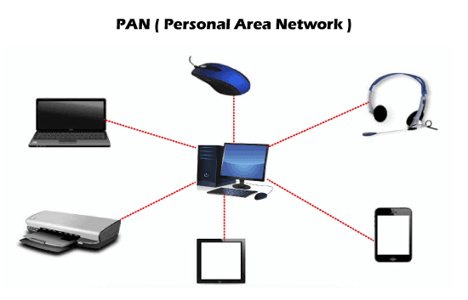

***PAN or Personal Area Network*** is a type of network used personally and usually serves one person. This network usually connects devices unlike your smartphones, laptop, or desktop to sync content and share small files, unlike songs, photos, videos, calendars, etc. These devices connect via **wireless networks such as Wi-Fi, Bluetooth, Infrared, etc.**

6. SAN

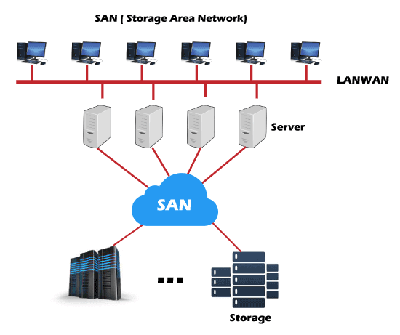

***SAN or Storage Area Network*** is a specialized high-speed network that stores and provides access to block-level storage. It is a dedicated shared network that is used for cloud data storage that appears and works like a storage drive.

SAN consists of various **switches, servers, and disks array.** One of the advantages of SAN is that it is fault-tolerant, which means if any switch or server goes down, the data can still be accessed.

7. VPN

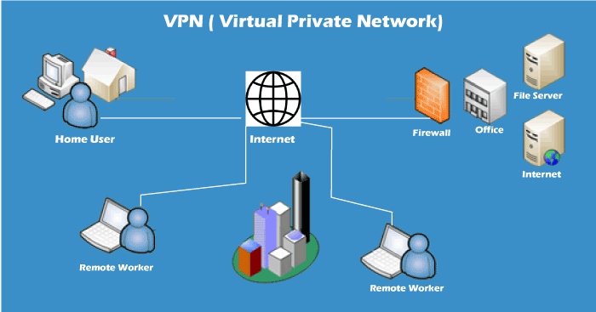

***VPN or Virtual Private Network*** is a secure tool that encrypts point-to-point Internet connection and hides the user's IP address and virtual location. It determines an encrypted network to boost user's online privacy so as their identity and data are inaccessible to hackers.

8. WAN

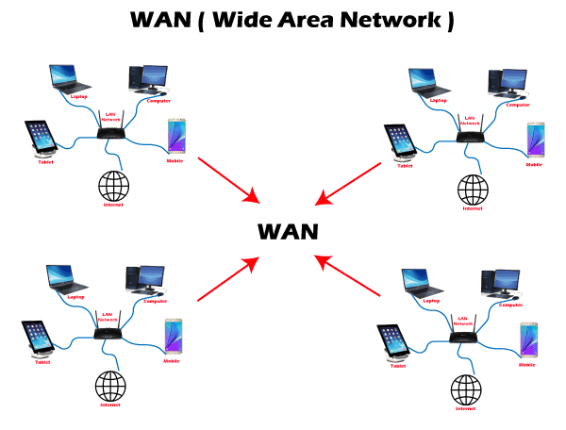

***WAN or Wide Area Network*** is the most significant network type connecting computers over a wide geographical area, such as a country, continent. WAN includes **several LANs, MANs, and CANs.** An example of WAN is the **Internet,** which connects billions of computers globally.

Networking terms and concepts

Some of the most commonly used terms in day-to-day networking life are as discussed below:

1. IP address

An IP address or ***Internet Protocol*** is a **unique number that represents the address where you live on the Internet.** Every device that is connected to the network has a string of numbers or IP addresses unlike house addresses.

You won't find two devices connected to a network with an identical IP address. When your computer sends data to another different, the sent data contains a 'header' that further contains the devices' IP address, i.e., the source computer and the destination device.

2. Nodes

A node refers to a networking **connection point where a connection occurs inside a network that further helps in receiving, transmitting, creating, or storing files or data.**

Multiple devices could be connected to the Internet or network using wired or wireless nodes. To form a network connection, one requires two or more nodes where each node carries its unique identification to obtain access, such as an IP **address.** Some examples of nodes are **computers, printers, modems, switches, etc.**

3. Routers

A router is a **physical networking device, which forwards data packets between networks.** Routers do the data analysis, perform the traffic directing functions on the network, and define the top route for the data packets to reach their destination node. A **data packet** may have to surpass multiple routers present within the network until it reaches its destination.

4. Switches

In a computer network, a switch is a device that **connects other devices and helps in node-to-node communication by deciding the best way of transmitting data within a network (usually if there are multiple routes in a more extensive network).**

Though a router also transmits information, it forwards the information only between networks, whereas a switches forwards data between nodes present in a single network.

Switching is further classified into three types, which are as follows:

* **Circuit Switching**
* **Packet Switching**
* **Message Switching**
* **Circuit Switching:** In this switching type, a secure communication path is established between nodes (or the sender and receiver) in a network. It establishes a dedicated connection path before transferring the data, and this path assures a good transmission bandwidth and prevents any other traffic from traveling on that path. For example, **the Telephone network.**
* **Packet Switching:** With this technique, a message is broken into independent components known as packets. Because of their small size, each packet is sent individually. The packets traveling through the network will have their source and destination IP address.
* **Message Switching:** This switching technique uses the store and forward mechanism. It sends the complete unit of the message from the source node, passing from multiple switches until it reaches its intermediary node. It is not suitable for real-time applications.

5. Ports

A port **allows the user to access multiple applications by identifying a connection between network devices.** Each port is allocated a set of string numbers. If you relate the IP address to a hotel's address, you can refer to ports as the hotel room number. Network devices use port numbers to decide which application, service, or method is used to forward the detailed information or the data.

6. Network cable types

Network cables are used as a **connection medium between different computers and other network devices.** Typical examples of network cable types are **Ethernet cables, coaxial, and fiber optic.** Though the selection of cable type usually depends on the size of the network, the organization of network components, and the distance between the network devices.

Computer Networks and the Internet

The Internet is the major example of a WAN, which connects billions of computers globally. Internet follows standard protocols that facilitate communication between these network devices. Those protocols include:

1. **HTTP (Hypertext Transfer Protocol)**
2. **IP (Internet protocol or IP addresses)**
3. **TCP (Transmission Control Protocol)**
4. **UDP (User Datagram Protocol)**
5. **FTP (File Transfer Protocol)**

**ISPs (Internet Service Providers) NSPs (Network Service Providers)** effectively support the internet infrastructure. The infrastructure allows the transportation of data packets to the recipient device over the Internet.

Internet is a giant hub of information, but this information is not sent to every computer connected to the Internet. The protocols and infrastructure are responsible for managing to share the precise information the user has requested.

How do they work?

1. The **Computer networks are formed by connecting multiple nodes** such as computers, desktops, routers, hubs, and switches with the help of either wired cables (Ethernet, data cables, fiber optics) or wireless networks (Bluetooth, Wi-Fi). This network connection enables the nodes to communicate and exchange data over the network.
2. Networks **follow communication protocols to send, receive, create or forward data.** Each note connected with a network is allocated a unique IP (Internet Protocol), the IP address used to identify a device and enables the other devices to identify it.
3. **Routers and Switches are the virtual or physical medium that supports and manages the communications** between networks. Routers examine the data packets to conclude the best route, following which the data can easily reach its destination node. In contrast, Switches connect the devices if there are multiple routes in a more extensive network and facilitate node-to-node communication, ensuring that the data packets traveling across the network reach their destination node.

Network Topology

**"Network topology is defined as the arrangement of computers or nodes of a computer network to establish communication among all."**

A node refers to a device that can transmit, receive, create, or store information. The nodes are connected via a network link that could be either wired (cables, Ethernet) or wireless (Bluetooth, Wi-Fi).

To help build a successful network in different situations, topologies are further classified into several types.  
Though there are several topologies but in this tutorial, we will discuss the commonly used ones, which are as follows:

1. Bus Topology

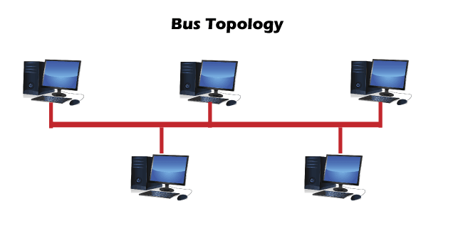

* A ***Bus network topology*** supports a common transmission medium where each node is directly connected with the main network cable.
* The data is transmitted through the main network cable and is received by all nodes simultaneously.
* A signal is generated through the source machine, which contains the address of the receiving machine. The signal travels in both the direction to all the nodes connected to the bus network until it reaches the destination node.
* Bus topology is not fault-tolerant and has a limited cable length.

2. Ring Topology

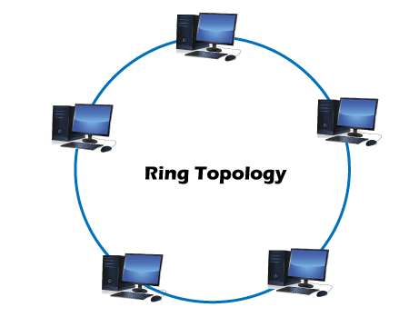

* A ***Ring topology*** is a modified version of bus topology where every node is connected in a closed-loop forming peer-to-peer LAN topology.
* Every node in a ring topology has precisely two connections. The Adjacent node pairs are connected directly, whereas the non-adjacent nodes are indirectly connected via various nodes.
* Ring topology supports a unidirectional communication pattern where sending and receiving of data occurs via **TOKEN.**

3. Star Topology

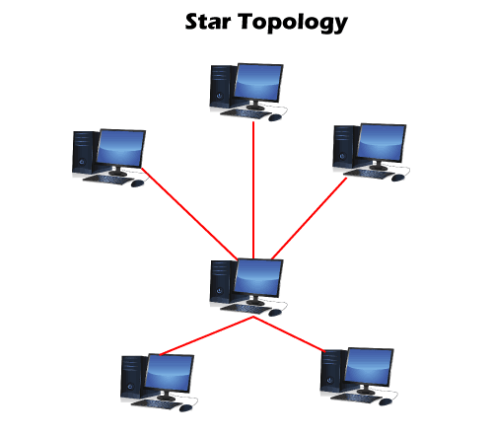

* In a ***Star network topology,*** every node is connected using a single central hub or switch.
* The hub or switch performs the entire centralized administration. Each node sends its data to the hub, and later hub shares the received information to the destination device.
* Two or more-star topologies can be connected to each other with the help of a repeater.

4. Mesh Topology

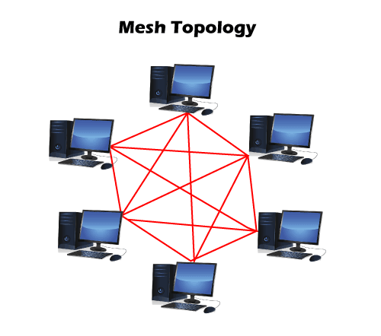

* In a ***Mesh topology,*** every node in the network connection is directly connected to one other forming overlapping connections between the nodes.
* This topology delivers better fault tolerance because if any network device fails, it won't affect the network, as other devices can transfer information.
* The Mesh networks self-configure and self-organize, finding the quickest, most secure way to transmit the data.
* One can form a full mesh topology by connecting every single node to another node in the network. **Full mesh** is expensive and is only used in the networks, which demands high data redundancy.
* Another type of mesh topology is **partial mesh topology,** where only a few devices are connected, and few are connected to the devices with which they share the most information. This mesh type is applicable in the networks, requiring less redundancy or a cost-effective network topology that is easy to execute.